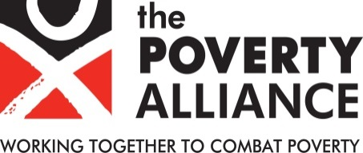
Equal Opportunities Monitoring Form

Position Applied for: Finance Officer
Reference: FO2021

Please provide the following information in order to help the Poverty Alliance ensure that its Equal Opportunities Policy is being effectively implemented. This information will be used solely for monitoring purposes. It will be treated as confidential and will not form part of the selection procedure for the post.

Ethnicity
Ethnicity is not about nationality, place of birth or citizenship. It is about the group
to which you perceive you belong. Please tick the appropriate box.
White:
Scottish |  | English
Welsh |  | Northern Irish
Irish |  | British
Gypsy or Irish Traveller
Other white background
Mixed or multiple ethnic groups
White and Black Caribbean |  | White and Black African
White and Asian |  | Any other mixed (state)
Asian / Asian British
Bangladeshi |  | Indian
Pakistani |  | Chinese
Other Asian background
Black / African / Caribbean / Black British
Black African |  | Black Caribbean
Any other Black background
Other ethnic group
Arab
Any other background (please state)
Prefer not to say

Sexual Orientation
My sexual orientation is:
Heterosexual/straight |  |  | Bisexual
Gay man |  |  | Gay woman/lesbian
Prefer not to say

Gender
My gender is
Female |  |  | Male
Transgender |  |  | Gender non-conforming
Non-binary |  |  | Prefer not to say

Disability
The Equality Act 2010 defines a disability as a "physical or mental impairment
which has a substantial and long-term adverse effect on a person's ability to carry
out normal day-to-day activities". An effect is long-term if it has lasted, or is likely to
last, more than 12 months. Are your day-to-day activities limited because of a health problem or disability which has lasted, or is expected to last, at least 12 months?
Yes – limited a little |  | Yes – limited a lot
No |  | Prefer not to say

Age
Age
17-24 |  | 25-34 |  | 35-44 |  | 45-54 |  | Over 55

Martial Status
Are you married or in a civil partnership?
Yes
No |  | Prefer not to say

Religion or Belief
What is your religion or belief?
No religion or belief |  |  | Buddhist
Christian |  |  | Hindu
Jewish |  |  | Muslim
Sikh |  |  | Prefer not to say
Other, please state if you wish

How did you hear of this vacancy?
Newspaper (which one?) _______________________________________
Other (please specify) ________________________________________

Please return this form to Sinead Howell by email to sinead.howell@povertyalliance.org or by post to:

The Poverty Alliance, 3rd Floor, 94 Hope Street, Glasgow, G2 6PH

